# Compass - Introduction to the Benefits Tab

Overview

Benefits Tab Example 1

Benefits Tab Example 2

Exception Rules

Related Documents

**Description:** Outlines the **Benefits** tab and related screens in Compass.

|  |
| --- |
| **Overview** |

The **Benefits** tab is accessed from the Member Snapshot Landing Page **Quick Actions** panel and displays an overview of the member’s plan benefits for the member’s account in one location. Depending on the client’s plan design, the view of the member’s **Benefits** will vary.

Review the **Example 1** and **Example 2** images below and **click the image** that resembles the **Benefits** tab for the member’s account in order to view the descriptions of each tab/field:

Benefits Tab Example 1

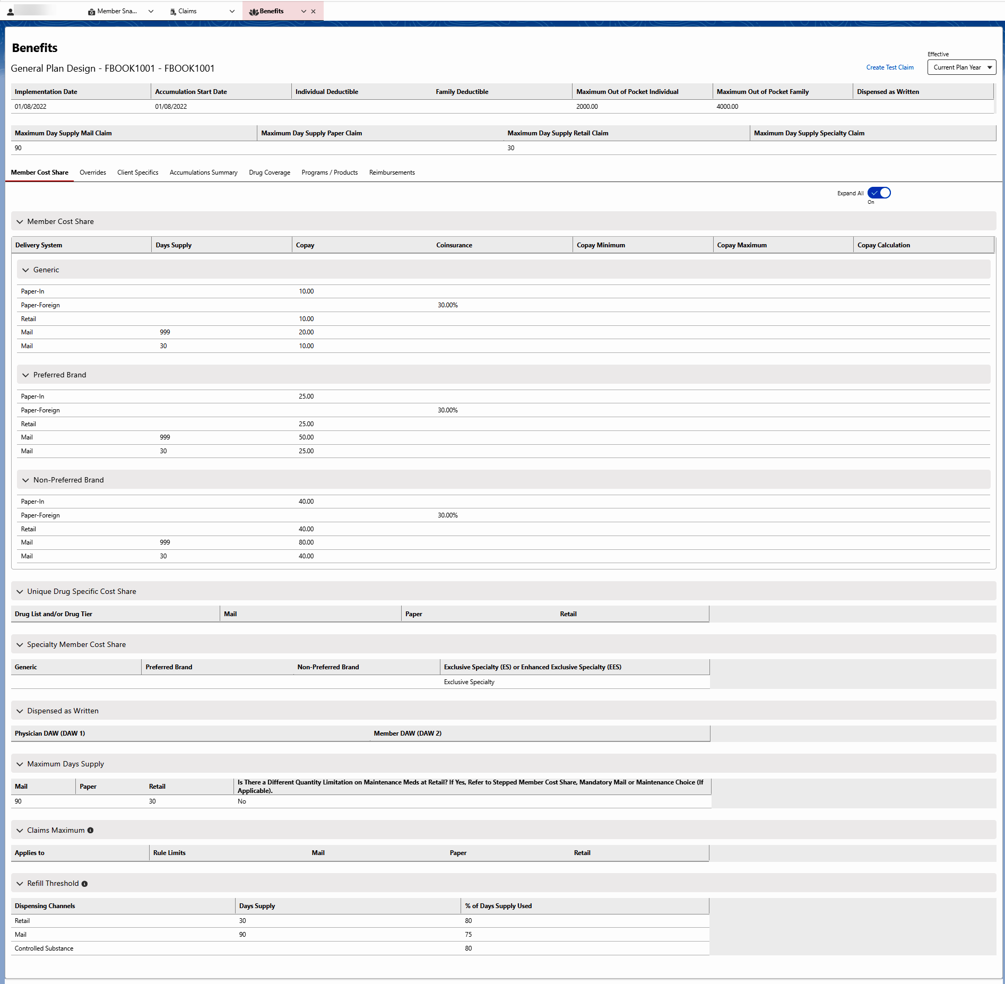

Benefits Tab Example 2

Top of the Document

|  |
| --- |
| **Benefits Tab Example 1** |

The Benefit Summary Screen is divided into four sections. All four sections will contain the Plan Design applicable to the category displaying in the section:

* Section 1: Contains **Retail/Mail** **Max Days** and **Utilization - % Used** along with **Retail/Mail Claims – Brand Drugs**
* Section 2: Contains **Retail/Mail Claims – Generic Drugs**
* Section 3: Contains **Paper Claims – Brand Drugs** information
* Section 4: Contains **Paper Claims – Generic Drugs** information

**Notes:**

* **Effective** drop-down menu options are Current Plan Year, Previous Plan Year, and Future Plan Year.
* Overrides and Client Specifics are for Current Plan Year only.
* If the plan displays Tiering tabs, refer to the Tiering section.
* 99 or 999 in any field acts as a default for unlimited. Review other related fields for additional limitations that may be applicable and negate the unlimited parameter.
* When using the RxClaim system for adjudication, the processed claims are reviewed against what has been filled through both Retail and Mail. The next refill will be based on the Utilization Rate. The Utilization Rate is based on the last location where the same medication was purchased. This information displays on the Plan Summary screen.

**Example:** A Retail fill delays mail order fill until the Retail Utilization rate has passed.

**To view Details** for a section, click the chevron arrow  to expand/collapse the desired section(s).

**Example:**

**Note:**For brand drugs, Compass displays the copay information for all three drug sources:

* Multi = Brand only, 2+ Manufacturers
* Single = Brand only, 1 Manufacturer
* Original = Brand w/ Generics Available

**Plan Design Tiering**

**Notes:**

* If a plan (or client) has a multi-tier formulary. Agent can select and view Tier specific copay.
* The number of tiers can vary based on the Client.
* The actual Tier a medication falls under can be indicated through navigating to the Claims Landing Page, clicking the Rx Number hyperlink, and selecting the **Drug** tab. Refer to [Compass - Claims Landing Page (049993)](https://thesource.cvshealth.com/nuxeo/thesource/#!/view?docid=c8f0ac8f-b076-4187-944d-2cf65b0ec799).

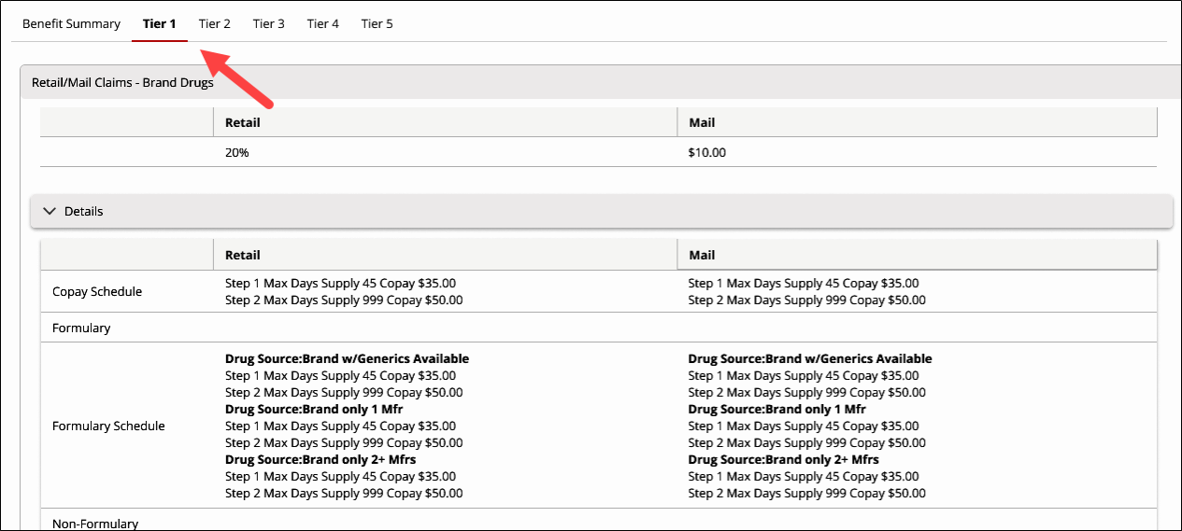

**Three Level Tiers**

|  |  |
| --- | --- |
| **Tier** | **Explanation** |
| **1 Preferred Generic** | Commonly prescribed generic drugs. |
| **2 Preferred Brand** | Brand name drugs that do not have a generic equivalent. They are the lowest cost brand name drugs on the drug list. |
| **3 Non-Preferred drug** | Higher priced brand name and generic drugs not in a preferred tier. |

**Six Level Tiers**

|  |  |
| --- | --- |
| **Tier** | **Explanation** |
| **1 Preferred Generic** | Commonly prescribed generic drugs. |
| **2 Generic** | Generic drugs, but they cost a little more than drugs in Tier 1. |
| **3 Preferred Brand** | Brand name drugs that do not have a generic equivalent.  Lowest cost brand name drugs on the drug list. |
| **4 Non-Preferred drug** | Higher priced brand name and generic drugs not in a preferred tier. |
| **5 Specialty** | Most expensive drugs on the drug list. Specialty drugs are used to treat complex conditions like Cancer and Multiple Sclerosis. They can be Generic or Brand name. |
| **6 Select Care** | Generic drugs used to treat diabetes and high cholesterol. |

**Field Descriptions**

|  |  |
| --- | --- |
| **Field** | **Description** |
| **Brand** | Copay assigned to Brand medications. |
| **Generic** | Copay assigned to Generic medications. |
| **Standard/Brand** | Low copay, usually same as Preferred. |
| **Formulary** | Copay for a Preferred drug from the formulary list. |
| **Non-Formulary** | Copay for medications not on the formulary. |
| **Brand/Formulary/Non-Formulary Copay Schedule** | How the copays are applied; for instance, one copay for every 30-day supply.  **Example:** Based on Max Day Supply 999 (unlimited) apply a factor of 1.00 (one copay). If a Brand copay is $40, member copay would be $40. |
| **Max Day** | Maximum day supply limitation allowed by the plan for claims payment. |
| **Utilization** | Percentage of medication to be used before the plan will pay for refills. |

**Paper Claim – Brand Drugs**

This screen allows the agent to view Paper Claim copay structure for **Brand Drugs** (In Network and Out of Network).

**Note:**For brand drugs, Compass displays the copay information for all three drug sources:

* Multi = Brand only, 2+ Manufacturers
* Single = Brand only, 1 Manufacturer
* Original = Brand w/ Generics Available

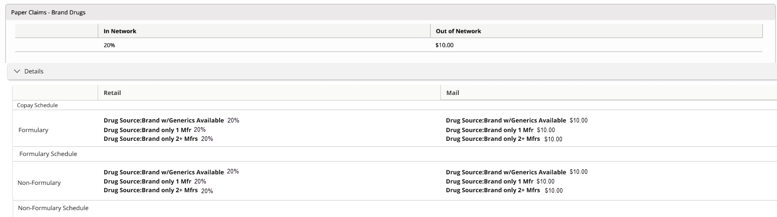

**Paper Claim – Generic Drugs**

This screen allows the agent to view Paper Claim copay structure for **Generic Drugs** (In Network and Out of Network Paper Claims).

Top of the Document

|  |
| --- |
| **Benefits Tab Example 2** |

The top of the screen includes the following information:

* General Plan Design name
* **Effective** drop-down options for Current Plan Year, Previous Plan Year and Future Plan Year.
* General plan information such as Deductibles and Maximum Out of Pocket amounts, Dispensed as Written rules, and other details.

Tabs found under the General Plan Design are:

* Member Cost Share
* Overrides
* Client Specifics
* Accumulations Summary
* Drug Coverage
* Programs / Products
* Reimbursements

**Note:** In the sections below, some fields will either have a Yes or No indication:

* Yes, is if the client allows/participates
* No, is if the client does not allow/participate

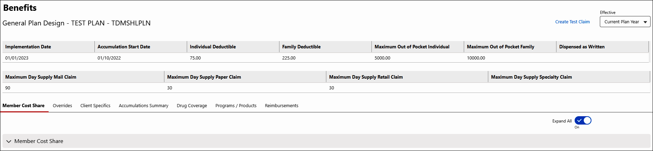

Refer to the following table for details regarding the information provided within each tab:

**Note:** Not all plans have Tiers. If a section is blank, the plan does not have that plan component.

|  |  |  |  |  |  |  |  |
| --- | --- | --- | --- | --- | --- | --- | --- |
| **Tab Name** | **Details** | | | | | | |
| **Member Cost Share**  **(Default)** | Displays the following collapsible sections on the left:    Refer to the following regarding the information provided within each collapsible section:   * Member Cost Share * Unique Drug Specific Cost Share * Specialty Member Cost Share * Dispensed as Written * Maximum Day Supply * Claims Maximum * Refill Threshold | | | | | | |
| **Section** | **Details** | | | | | |
| Member Cost Share | Displays out-of-pocket costs (copayment) for the covered care the member received. If the plan has stepped cost the tier steps will be included. | | | | | |
| **Field** | | | | | **Description** |
| Delivery System | | | | | Indicates which distribution channels are available to this member, such as:   * Mail Order Pharmacy (MOR) * Paper Claims (PCL) * Retail Pharmacy (POS) |
| Days’ Supply | | | | | The number of days’ worth of medication allowed by the prescription benefit plan. |
| Copay | | | | | Plan member’s share of the prescription drug cost. Client sets a standard and/or generic flat dollar copay. |
| Coinsurance | | | | | A fixed percentage amount required to be paid by the member before or after meeting an established policy deductible. |
| Copay Minimum | | | | | The minimum amount a plan member will pay on a coinsurance based plan. |
| Copay Maximum | | | | | The maximum dollar amount a plan member will pay on a coinsurance based plan. |
| Copay Calculation | | | | | DO NOT USE. |
| Generic | | | | | Copay assigned to generic medications. |
| Brand | | | | | Copay assigned to brand medications. |
| Non-Preferred Brand | | | | | Copay for medication not on the formulary. |
| Unique Drug Specific Cost Share | Displays any drugs for which the plan has special provision. **Example:** Smoking cessation | | | | | |
| Specialty Member Cost Share | Displays Member cost share for Specialty medications. | | | | | |
| Dispensed as Written | Displays plan rules for specific DAW codes. | | | | | |
| Maximum Day Supply | Displays maximum day supply for each type of claim.   * INN = In network * ONN = Out of network | | | | | |
| Claims Maximum | Displays maximum dollar amount of an individual claim allowed by the plan. (Tool Tip icon  “Maximum dollar amount that the plan will pay per claim. When Exclusive Specialty benefit is selected Claim Maximum is not applied to Specialty products.”) | | | | | |
| Refill Threshold | Displays the percentage of days’ supply which must be used before a refill is allowed. (Tool Tip icon  “The percentage of day’s supply that must be used before a system will allow a refill.”) | | | | | |
| **Overrides** | Refer to the following table for additional information:  **Notes:**   * Use the **Tool Tip:**  in the **Override Type** field to display a description of each override. * If a Work Instruction name hyperlink is displayed, clicking the hyperlink will open theSource and the Work Instruction will display. * When a hyperlink displays in any field a work instruction name, but as an URL, a work instruction will display after clicking the hyperlink. | | | | | | |
| **Override Types** | **Notes** | | | | | |
| Vacation | * Overrides are displayed in order of usage. * Each override section will have its own Exception Rules section. For additional information about the fields in this section, refer to the Exception Rules section below. * Submit Support Task will be displayed in the Allowed fields with the Tool Tip:  Create an Override Support Task and include any details regarding the request for consideration. * Submit Support Task will be a hyperlink to the Create Support Task tab. * Create Override/PA button will display in the upper-right corner of the Overrides tab.   + All functionalities will be the same as clicking Create Override/PA from the Quick Actions panel on the Claims Landing Page.   + The Create Override/PA button will only be available in an Interaction Case or when the user has permission to create an override from a Research Case. * Override/PA History button will be displayed to the left of the Create Override/PA button. * The Override/PA History button will be the same Override/PA History tab located in the Quick Actions panel on the Claims Landing Page. * Submission Clarification Code (SCC) field will display for Vacation, Lost Medication, Stolen Medication, Damaged Medication, Dosage Change, and Disaster Emergency Override types only.   + When client allows SCC codes to be used, the appropriate SCC code will display in this field.   + When client does not allow SCC codes to be used, No will display in this field. | | | | | |
| Lost Medication |
| Duplicate Therapy |
| Dosage Change |
| Dose Optimization |
| Maximum Dollar |
| Damaged Medication |
| Stolen Medication |
| Retail Fill Limit |
| Nursing Home/Long Term Care |
| Incorrect Days’ Supply |
| Multiple Births |
| Maximum Drug Limit/Quantity vs Time |
| Disaster Emergency |
| Manufacturer Back Order |
| Drugs with Extended Days’ Supply |
| Transition Fill |
| OIG/Excluded Provider Edit |
| Exclusive Specialty |
| Hospice |
| End Stage Renal Disease (ERSD) |
| Mail Order Delay |
| Participant Mail In Delay |
| Expatriate Employees |
| **Client Specifics** | Displays the following information:   * Client Effective Date * Client Term Date * Restricted Data Client - Tool Tip icon  "Indicates if the client allows for offshore agents ("No" signifies offshore is allowed) * Test ID’s - Tool Tip icon  "Universal/Test ID numbers are used to run test claims and/or view plan changes to compare plans" * ID Card Handled By * Mail Tags - Tool Tip icon  "Indicates whether or not a Client allows mail ordered prescriptions to be returned" * Mail Order Bulk Up - Tool Tip icon  "This refers to scenarios where a member was expecting a 3 month supply, but the prescription was written as a 1 month supply" * Eligibility Handled By * Newborn Coverage * Medicare B vs. D - Tool Tip icon  "Determines Part B vs. D outcomes for medications and supplies" * OTC Benefits - Tool Tip icon  "Over the Counter (OTC) benefits are for drug and health-related products that do not need a prescription" * Web Support - Tool Tip icon  "Who assists with client website support"   + Available Options to Display:     - **Caremark.com** will display with the link to Caremark.com and any additional information if needed.     - **Single Sign On (SSO)** will display with the Website URL, phone number, and any additional information provided by the client.     - **Other** will display with the Website URL, phone number, and any additional information provided by the client.     **Note:** If a Work Instruction name hyperlink is displayed, clicking the hyperlink will open theSource and the Work Instruction will display.  Refer to the following regarding the information provided within each collapsible section:   * Phone Number(s) * PA and Appeals * Exception Process * Coordination of Benefits (COB) * Helpful Links in theSource | | | | | | |
| **Section** | | **Details** | | | | |
| Phone Number(s) | | Displays phone number(s) for the following call types:   * Customer Care * Client Customer Care * Pharmacy Help Desk * Internal/Backdoor * Mail Member * Retail * After Hours * Other | | | | |
| PA and Appeals | | Displays:   * Handled By (Caremark, Client, Other) * Submission Information * Phone Number * Fax Number | | | | |
| **Field** | | | **Description** | |
| PA | | | Health plan cost-control process that restricts patient access to treatments, drugs, and services. This process requires physicians to obtain health plan approval before delivery of the prescribed treatment, test, or medical service to qualify for payment. | |
| Appeals | | | If you disagree with your plan's decision about whether to provide or pay for a drug. | |
| Appeals – External Review | | | External reviewer issues a final decision: An external review either upholds your insurer's decision or decides in your favor. | |
| Exception Process | | Displays:   * Handled By (Caremark, Client, Other) * Submission Information * Phone Number * Fax Number | | | | |
| **Field** | | | **Description** | |
| Affordable Care Act | | | In determining whether a generic is medically appropriate, a plan may use a reasonable exception process. | |
| Compounds | | | As an exception if there is a medical need for a (bulk) ingredient to be added to a compound. | |
| DAW | | | Allows for coverage of the brand drug without paying the difference in cost between brand and generic. | |
| Tier Exception | | | A type of exception request through the Part D appeal process. You can request lower cost-sharing for a prescription on a higher tier if you show that similar drugs on the formulary at lower tiers are ineffective or harmful. | |
| Coordination of Benefits (COB) | | Displays the following fields:   * Online COB * Medicaid COB * COB RxBIN * COB RxGRP * COB RxPCN * Alternate Insurance (reject 41) Handled By | | | | |
| Helpful Links in theSource | | Displays links to theSource for each of the following categories:   * Annual Notice of Change * Drug List * Formulary Disruptions * Job Aids * Letter Templates * Reference Table * Talk Tracks * Training Materials * Work Instructions | | | | |
| **Accumulations Summary** | Accumulations Summary will only show limits, will not show amount paid to date towards that accumulation.    Refer to the following regarding the information provided within each collapsible section on the left:   * Summary * Deductible (DED) * Alternate Deductible (DED) * Maximum Out of Pocket (MOOP) * Alternate Maximum Out of Pocket (MOOP) * Maximum Allowable Benefit (MAB) | | | | | | |
| **Section** | | **Details** | | | | |
| Summary | | Displays the type of year the plan uses for accumulations.  **Examples:** Calendar, Fiscal. | | | | |
| Deductible (DED) | | Displays information regarding deductibles for the plan. | | | | |
| Alternate Deductible (DED) | | Displays any alternate deductible information for the plan. | | | | |
| Maximum Out of Pocket (MOOP) | | Displays the maximum amount the member will pay. May vary based on dispensing channel. | | | | |
| Alternate Maximum Out of Pocket (MOOP) | | Displays information for medication that requires special handling. | | | | |
| Maximum Allowable Benefit (MAB) | | Displays the maximum amount that will be covered, during a specified time frame, under a member's plan design.   * MAB can also apply to specific medication, such as fertility drugs. * Not all plans have a MAB. | | | | |
| **Drug Coverage** | This section will display drug coverages. The coverage will vary by client. | | | | | | |
| **Section** | | | **Details** | | | |
| Coverages | | | The following sections will display. Each section will have fields for **Drug/Drug Lists** and **Drug Coverage**.  **Note:** The **Drug Coverage** section will display “Covered” or “Not Covered.” Run Test Claims for drug specific limitations/PA information.   * Allergy Serum * Contraceptive * Core Compound Services * Drugs * General Categories * Injectable Diabetic Medicines * Nutritional Supplements * Specialty Medications | | | |
| Affordable Care Act (ACA) Drug Coverage | | | In this section, ACA covered drugs covered by the plan can be viewed.  The following fields will display:   * Drug Category * Coverage * Custom Message | | | |
| **Programs/Products** | Refer to the Tool Tip icon   next to each program name for a program overview.  **Note:** If a program section is not expanded when clicking on the **Program/Products** tab, click the **chevron** next to the program name to expand it. | | | | | | |
| **Section** | | | | **Details** | | |
| Specialty Starter Fill | | | | **Tool Tip:** The Specialty Starter fill program limits the quantity dispensed for targeted therapies to a 14 or 15 day supply based on product packaging.  The following fields will display:   * Drug List * Look Back Period * Copay Adjustment * Refill Too Soon Threshold * Reject Message | | |
| Specialty Copay Enrollments | | | | **Tool Tip:** Plan shall exclude from coverage certain drugs that have limited clinical value and which have clinically appropriate, lower-cost alternatives (**Example:** Brand name drugs that are combinations of existing generic or over- the-counter drugs, new formulations of existing drugs).  The following fields will display:   * **True Accumulations** – When the hyperlink is clicked, a pop-up displays **True Accumulation** with the following information: "When a member uses a copay card for a specialty drug filled at a CVS Specialty pharmacy, it ensures only true member cost share (non-party dollars) are applied towards members accumulations (Deductible and Out of Pocket)." * **Copay Optimization** – When the hyperlink is clicked, a pop-up displays **Copay Optimization** with the following information: "Update member cost share at the drug and/or therapy level to the value of the non-financial needs based assistance cards included in the program." * **Prudent Rx** - Designed to help clients incrementally manage specialty pharmacy spend. The solution uses an innovative plan design that targets all specialty medications, including those in highly utilized classes such as Hepatitis C, Autoimmune, Oncology and Multiple Sclerosis, to create maximum value for clients while providing plan members with zero out-of-pocket costs. It requires True Accumulations, Exclusive Specialty or Enhanced Exclusive Specialty, Advanced Control Specialty Formulary (ACSF) or a formulary that utilizes the ACSF approach for Specialty, such as ACF (Advanced Control Formulary), Balanced Formulary, and Value Formulary. This plan design increases the member coinsurance on Essential Covered Specialty medications to 30%. Members enrolled in PrudentRx copay program will have a $0 out of pocket cost. This program utilizes ACA standards for Essential Health Benefits (EHB) and maximum-out-of-pocket (MOOP) limits. | | |
| Maintenance Choice | | | | **Tool Tip:** Maintenance Choice® is a unique 90-day plan design offering both savings and a seamless member experience. With Maintenance Choice, members have the opportunity to choose how they fill their prescriptions - at CVS/pharmacy or by mail - at the same low copay, while clients enjoy the benefit of low mail pricing regardless of where members fill.  The following fields will display:   * Dispensing Channels * Plan Type * Level * Fill History to be Reviewed * Retail Day Supply * Number of Fills Allowed before Penalty (blank when MCH voluntary) * Fill Rule Applies to (**Example:** Maintenance Drugs) * Mandatory Opt-Out Option | | |
| Incentivized Maintenance Choice Penalty | | | | **Tool Tip:** Maintenance drug penalty patient pay after number of retail fills met.  The following fields will display:   * Drug Tier * Copay * Coinsurance * Copay Minimum * Copay Maximum * Copay Calculation | | |
| Mandatory Mail (Non-Maintenance Choice) | | | | Plan offering in which the member is limited to a certain number of 30-day supply fills at a retail pharmacy. After the limit is reached, the medication will only be covered in 90-day supplies through home delivery. If the member continues to fill 30-day supplies, they will not be covered by the plan. It is client-specific, with the client determining how many 30-day supply fills will be covered.  The following fields will display:   * Dispensing Channels * Plan Type * Mandatory Opt-out Drug Level Options * History to be Reviewed * Fill Rule Applies to (**Example:** Maintenance Drugs) * Max Number of Fills Allowed | | |
| Caremark Cost Saver | | | | **Tool Tip:** Caremark Cost Saver Program utilizes a third-party contracted retail pharmacy network to enable plan members to take advantage of lower discount card prices, when available, while retaining the benefit of the drug utilization and clinical programs provided under the plan. **Note:** Amounts paid by members for Cost Saver Program claims will apply to plan deductible and out-of-pocket maximum accumulations, if applicable.  This will display any information entered by the client, if any. | | |
| RxSavings Plus for Non-Covered Drugs | | | | **Tool Tip:** RxSavingsPlus for Non-covered Drugs allows plan members to purchase certain medications not covered under the prescription plan at the full discounted cost.  This will display any information entered by the client, if any. | | |
| Drug Efficacy Study Indicator (DESI) Coverage Exception | | | | **Tool Tip:** DESI Indicator Code: Identifies a drug’s involvement in the Drug Efficacy Study conducted by the Food and Drug Administration (FDA). The DESI Indicator plan edit allows coverage to be restricted for products based on their DESI Indicator code rating.  This will display any information entered by the client, if any. | | |
| Drug Exclusion Plan Design Strategy | | | | Coming Soon! Refer to CIF. | | |
| ScriptSync | | | | Coming Soon! Refer to CIF. | | |
| **Reimbursements** | The following collapsible sections display common reimbursement types:    Compass will display the following information based on the members’ plan for **Member Submitted Paper Claims**:   * **Compound Claims Covered** * Plan Coordinates Benefits * Timely Filing Rule * Timeframe to File a Claim * **In-Network Pharmacy Claims Reimbursed Based On** * In-Network Reimbursement % if other than 100% * In-Network Grace Period * **Out-of-Network Pharmacy Claims Reimbursed Based On** * Out-of-Network Reimbursement % if other than 100% * Out-of-Network Grace Period * **International Claims Reimbursed Based On** * International Reimbursement % if other than 100% * International Grace Period * **Nursing Home Claims Reimbursed Based On** * Nursing Home Reimbursement % if other than 100% * Nursing Home Grace Period   **Note:** The Grace Period is the number of days from start of plan where member is reimbursed 100% submitted, after which time the contracted rate applies.  Compass will display the following information based on the members’ plan for **Coordination of Benefits (COB) Retail (Online)**:   * Reimbursement Level: Submitted * Reimbursement Level: Copay * Reimbursement Lovel: Coinsurance   Compass will display the following information based on the member’s plan for **Coordination of Benefits (COB) Paper (Manual)**:   * In-Network/Reimbursement * In-Network/Reimbursement Level   Compass will display the following information based on the members’ plan for **Government Agency Submitted Claims**:   * Authorize CVS Caremark to Process Government Agency Claims * Permit up to a 90 day supply to pay at the submitted day supply amount for VA claims (If yes, typically copays are stepped by day supply. Coinsurance is not stepped for a 90 day supply)   Compass will display the following information based on the members’ plan for **Stepped Member Cost Share (VA Claims)**:   * Drug Tier/ Drug List (generic, preferred brand, non-preferred brand) * Pharmacy Network * Day Supply/Fills * Delivery System * Copay * Coinsurance * Copay Minimum * Copay Maximum * Copay Calculations | | | | | | |

Top of the Document

|  |
| --- |
| **Exception Rules** |

When viewing the **Benefits** screen **Overrides** tab, each override will have an **Exception Rules** section, which can be expanded by clicking the chevron arrow.

**Example:** At the bottom of the **Vacation** section, there is an **Exception Rules** section.

**Notes:**

* The Exception Rule fields will always display, but the information in the fields will be dynamic based on the Client.
* Hovering over each Tool Tip  will display important information about the exception rule(s).

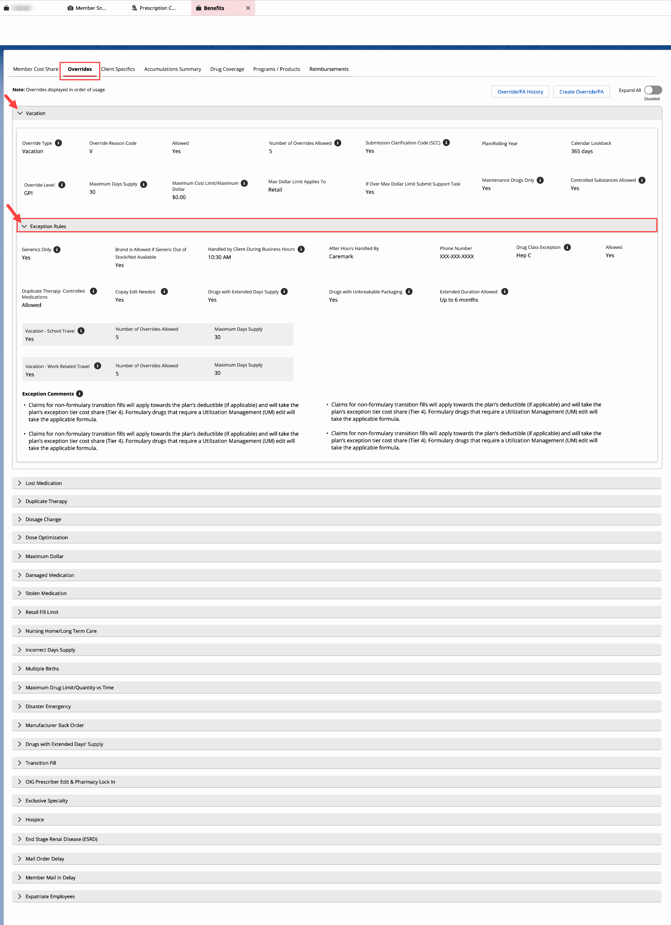

|  |  |
| --- | --- |
| **Exception Rules** | **Tool Tip  / Additional Information** |
| Generics Only | **Yes/No.** Override is only allowed to be entered for generic medications. |
| Brand is Allowed if Generic Out of Stock/Not Available | **Yes/No** |
| Handled by Client During Business Hours | Override must be entered by the client during their specified business hours displayed.  **Example:** 10:30 AM. |
| After Hours Handled By | Depends on the Client.  **Example:** Caremark. |
| Phone Number | This will display the phone number for the client that handles after hours. |
| Drug Class Exception | Overrides can or cannot be entered for a specific drug class.  **Example:** Hep C. |
| Allowed | **Yes/No.** |
| Duplicate Therapy – Controlled Medications | Only allowed for controlled, medications (C1-C5) if the Rx has matching provider and filling pharmacy.  **Example:** Allowed. |
| Copay Edit Needed | **Yes/No.** Copay edits may be required for specific processes. To allow the member to pay valid amount of coinsurance or copay for medication based on the plan setup, valid tier, and/or day supply. |
| Drugs with Extended Days’ Supply | **Yes/No.** If a plan has a 30 days’ supply limit, this override will allow a claim to pay at a higher days’ supply than plan allows (e.g., Trelstar - one injection lasts 168 days. |
| Drugs with Unbreakable Packaging | **Yes/No.** To allow for an override for a medication that has unbreakable packaging (e.g., insulin (Vial, pen), birth control, eye drops, creams, etc.). |
| Extended Duration Allowed | Period of time allowed by client for the specified reason code. (This is not to determine the days’ supply for the override.)  **Example:** Up to 6 months.  **Note:** This is for all override types. |
| Vacation - School Travel | To allow for an extended override for members traveling for school. Destination, departure, and return dates are required when requesting this type of override.  **Number of Overrides Allowed** **Example:** 5  **Maximum Days’ Supply Example:** 30 |
| Vacation - Work Travel | To allow for an extended override for members traveling for work. Destination, departure, and return dates are required when requesting this type of override.  **Number of Overrides Allowed Example:** 5  **Maximum Days’ Supply** **Example:** 30 |
| Exception Comments | Additional client exception information.  **Note:** Compass can display up to 10 Exception Comments for each override. |

Top of the Document

|  |
| --- |
| **Related Documents** |

[Customer Care Abbreviations and Definition and Terms Index (017428)](https://thesource.cvshealth.com/nuxeo/thesource/#!/view?docid=c1f1028b-e42c-4b4f-a4cf-cc0b42c91606)

Top of the Document

Not to Be Reproduced or Disclosed to Others without Prior Written Approval

**ELECTRONIC DATA = OFFICIAL VERSION / PAPER COPY = INFORMATIONAL ONLY**